Frontend Assignment Set

Module 1 – Foundation
Q.1 What is a HTTP?
Ans:- HTTP (Hyper Text Transfer Protocol) is a communication protocol that allows a web browser and a web server to talk to each other. HTTP is a set of rules used to transfer web pages from server to browser.
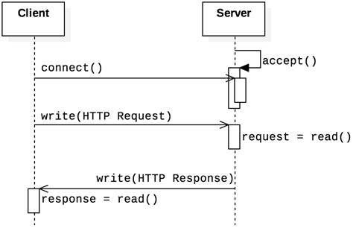

Q.2 What is a Browsers? How they works?
Ans:- A browser is a software application that helps you open, view, and use websites on the internet. Without a browser, you cannot access websites.

Examples:
- Chrome
- Firefox
- Edge
- Safari
- How Does a Browser Work?
- You type a website address (URL)
- Browser finds website IP using DNS
- Browser sends request to web server
- Server sends website data (HTML, CSS, images)
- Browser reads the data
- Browser displays the website on screen

Q.3 What is Domain Name?
Ans:- A domain name is the easy-to-remember name of a website that people type in a browser to visit a website. It points to the website’s IP address.
A domain name is the human-readable address of a website used to access it on the internet.
- How Domain Name Works
- You type a domain name in browser.
- Browser asks DNS for IP address.
- DNS returns IP address.
- Browser opens the website.

Q.4 What is hosting?
Ans:- Hosting is a service that stores your website files on a server and makes your website available on the internet 24/7. A server is a powerful computer that is always connected to the internet.
- Hosting stores all your website data, such as:
- HTML files
- CSS & JavaScript
- Images & videos
- Database (for dynamic websites)
These files are saved on a hosting server.

Module 2 – Fundamentals of World Wide Web
Q.1 Difference between Web Designer and Web Developer
Ans:-
 | Web Designer | Web Developer
1. | Web designers are the aesthetic element. | Web development refers to building user-friendly websites based on clients' specifications.
2. | They transform the ideas into visually appealing designs. | They transform designs into fully functional websites.
3. | Web designers refer to how the website looks and feels on the outside. | Web development refers to the functionality of the website on how it works.
4. | Web designers create the idea and style of a website, creating a mockup based on visual, UX, and UI features. | Web developers decide whether the concept is financially and technically feasible, and then only starts with further step of coding the site..
5. | The function of a web designer is concerned with the website's visual and creative aspects and less concerned with technicality. | Web developers must be technically savvy. This includes comprehending sophisticated programming languages and frameworks.
6. | Types of Web Designers-  - User Experience (UX)  - User Interface (UI)  - Visual/Graphic Designer | Types of Web Developers-  - Front-end  - Back-end  - Full-stack

Q.2 What is a W3C?
Ans:- World Wide Web Consortium is an international organization that creates rules (standards) to make sure the web works the same way for everyone, on all browsers and devices.
W3C defines standards for:
- HTML – structure of web pages
- CSS – design and layout
- JavaScript APIs – browser

Q.3 What is Domain?
Ans:- A Domain (Domain Name) is the human-readable address of a website on the internet. It helps users access websites without remembering IP addresses.
Example:-
www.google.com is a domain name
Q.4 What SEO?
Ans:- SEO [Search Engine Optimization] ia the process of improving the quality and quantity of website traffic to a website or a webpage from search engine. SEO targets unpaid traffic rather than direct traffic or a paid traffic.
Which is the process of getting traffic from free, Organic, Editorial, or natural search results in search engines.
It aims to improve websites position in search result pages. Remember the higher the website is listed: The more people will see it.
Q.5 What is SDLC life cycle?
Ans:- Which is a structured approach used by software developers to design, develop, test and deploy software applications. It provide systematic process to ensure creation of high quality software within a certain timeframe and budget.
Q.6 Explain phases of SDLC life cycle.
Ans:- The SDLC is divided into several stages, which typically include :
- Planning / Requirement Gathering
This phase involved understanding and documenting the business needs and technical requirements stakeholders discuss what features and functionalities the software should have.
- System Design
Based on the system requirement the system’s architecture and design are created. This could include a high-level structure of software, database design and user interface.
- Implementation (Coding)
The actual code is written in this phase. developers start building the software based on the design specification.
- Testing
Once the software is built, it goes through various tests to find and fix any bugs or issues. This ensures the software meets the required quality standards.
- Deployment
After testing, the software is deployed to the production environment, wher users can start using it.
- Maintenance
Once the software is live, it enters the maintenance phase, where updates, bug fixes and improvements are made as required by the user

Module 3 – Fundamentals of IT
- Explain in your own words what a program is and how it functions.
Ans :- A program is a set of clear, step-by-step instructions written in a programming language that tells a computer what to do and how to do it. These instructions are created by a programmer to solve a problem or perform a specific task, such as calculating numbers, displaying a webpage, or storing data.
How a program function :
- The programmer writes the program using a programming language (like C, Python, or Java).
- The computer converts this program into a form it can understand (machine code).
- When the program is executed, the computer follows the instructions one by one.
- The program takes input, processes it using logic or calculations, and produces output.
LAB EXERCISE: Write a simple "Hello World" program in two different programming languages of your choice. Compare the structure and syntax.
Ans:-
Output :-
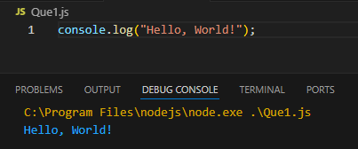
- What are the key steps involved in the programming process?
Ans :- The programming process focuses on building user-friendly and responsive interfaces. The key steps are:
- Understanding Requirements
Understand what kind of website or user interface is needed (UI design, features, responsiveness).
- UI/UX Planning
Decide page layout, navigation, components, and user flow (often using wireframes or mockups).
- Design Implementation
Convert designs into code using HTML for structure and CSS for styling.
- Adding Interactivity
Use JavaScript to handle user actions like button clicks, form submission, animations, and API data.
- Testing in Browser
Check how the website works in different browsers and screen sizes.
- Debugging
Fix layout issues, JavaScript errors, and performance problems.
- Optimization
Improve loading speed, responsiveness, and accessibility.
- Deployment & Maintenance
Upload the frontend code to a server and update it when new features or fixes are needed.
- What are the main differences between high-level and low-level programming languages?
Ans :-
S.No. | High-Level Language | Low-Level Language
1. | It can be considered as a programmer-friendly language. | It is considered as a machine-friendly language.
2. | It requires a compiler/interpreter to be translated into machine code. | It requires an assembler that would translate instructions.
3. | It can be ported from one location to another. | It is not portable.
4. | It is easy to understand. | It is difficult to understand.
5. | It is easy to debug. | It is difficult to debug.
6. | It is less memory efficient, i.e., it consumes more memory in comparison to low-level languages. | It consumes less memory.

- Describe the roles of the client and server in web communication.
Ans :- 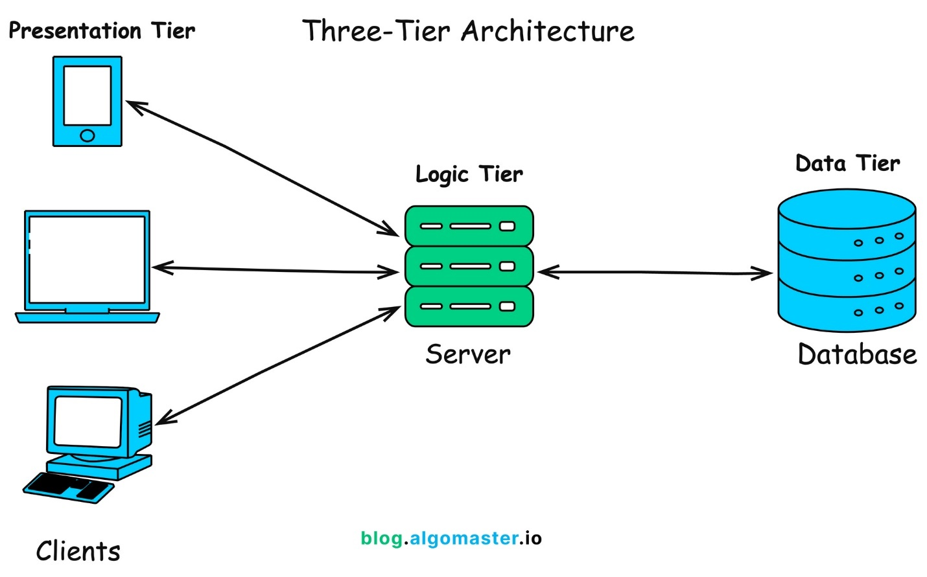
In web communication, the client and server work together to display and run a website.
- Role of the Client (Frontend Side)
The client is usually a web browser (like Chrome, Edge, or Firefox) that the user interacts with.
Client responsibilities:
- Sends requests to the server (page load, form submit, API call)
- Displays the website UI using HTML, CSS, and JavaScript
- Handles user actions like clicks, typing, scrolling
- Executes JavaScript in the browser
- Shows data received from the server
- Role of the server (Backend Side)
The server is a computer/system that stores data, processes requests, and sends responses back to the client.

Server responsibilities:
- Receives requests from the client
- Processes business logic
- Connects to databases
- Authenticates users
- Sends responses (HTML, JSON, images, etc.)
LAB EXERCISE: Research and create a diagram of how data is transmitted from a client to a serverover the internet.
Ans:- When a user types a URL or clicks a link in a browser, the browser + OS + network stack take these main steps:
- DNS lookup — resolve the domain name (e.g., example.com) to an IP address.
- TCP connection setup — the client and server establish a reliable transport connection (TCP 3-way handshake: SYN → SYN/ACK → ACK).
- Optional TLS handshake — if the site is https://, the client and server negotiate encryption keys (TLS) before sending HTTP payload.
- HTTP request/response — the client sends an HTTP request (GET/POST/etc.) over the established (and possibly encrypted) connection; the server responds with a status and payload (HTML, JSON, etc.).
- Routing & link hops — packets travel across multiple routers and network links; each IP packet is forwarded hop-by-hop until it reaches the destination host's network interface.
- Transport & reassembly — TCP handles ordering, retransmission, and reassembly of bytes into the original application data at the server side; the server’s application processes the request and replies.
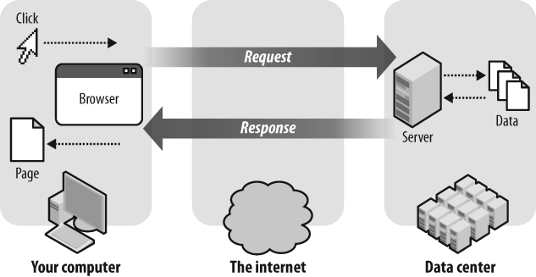

- Explain the function of the TCP/IP model and its layers.
Ans :-
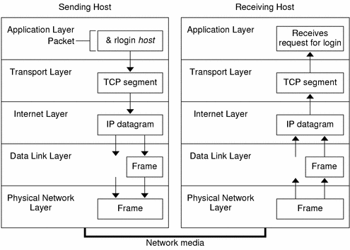
The TCP/IP model is a standard framework used to enable communication between computers over the internet. It defines how data is sent, routed, and received so that different devices and networks can communicate reliably.
- Function of the TCP/IP Model
- Provides rules for data communication over networks
- Ensures reliable data transfer between devices
- Breaks data into packets and reassembles them at the destination
- Allows communication between different hardware and operating systems
- Forms the foundation of the internet and web communication
- Layers of the TCP/IP Model
The TCP/IP model consists of four layers, each with a specific function.

1. Application Layer
- Closest to the user
- Provides network services to applications
- Handles data formatting and communication services
Examples: HTTP, HTTPS, FTP, SMTP, DNS

2. Transport Layer
- Ensures reliable data delivery
- Divides data into segments and reassembles them
- Handles error control and flow control
Protocols:
- TCP – Reliable, connection-oriented
- UDP – Fast, connectionless

3. Internet Layer
- Handles logical addressing and routing
- Determines the best path for data packets
Protocols: IP, ICMP

4. Network Access Layer
- Deals with physical transmission of data
- Converts data into signals for network hardware
Examples: Ethernet, Wi-Fi
LAB EXERCISE: Design a simple HTTP client-server communication in any language.
Ans:-
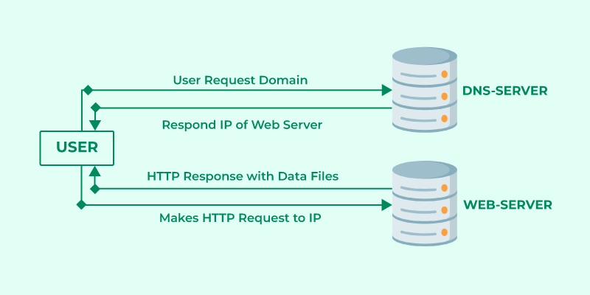
- Explain Client Server Communication
Ans :- 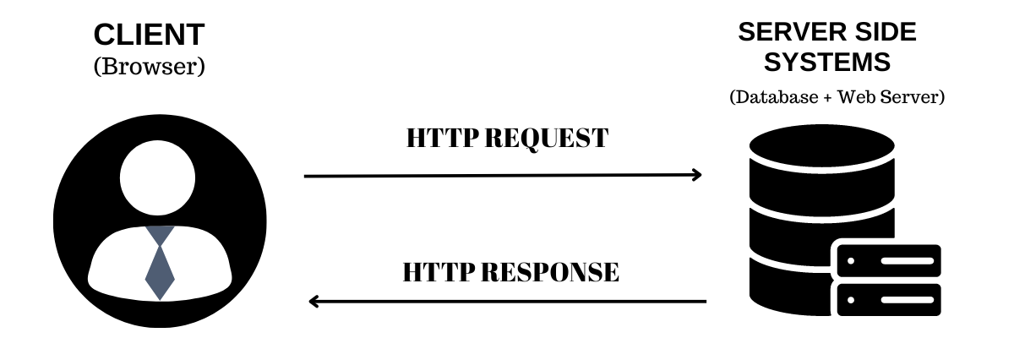
Client–server communication is a method where a client (such as a web browser) requests services or data from a server, and the server responds with the required information. This model is the foundation of how websites and web applications work.
- How Client-Server Communication Works
- The user performs an action (open a page, click a button, submit a form).
- The client sends a request to the server using protocols like HTTP or HTTPS.
- The server receives and processes the request.
- The server may interact with a database or perform logic.
- The server sends a response back to the client.
- The client displays the response to the user.

- How does broadband differ from fiber-optic internet?
Ans :- Broadband and fiber-optic internet are both high-speed internet technologies, but they differ in speed, reliability, and the type of cables used to transmit data.
- Broadband Internet
Broadband is a general term for high-speed internet access that is always on.
Characteristics:
- Uses copper cables (DSL, cable) or wireless signals
- Speed varies depending on distance and network load
- More affected by interference and weather
- Widely available and usually cheaper
Examples:
DSL, Cable internet, Mobile broadband (4G/5G)
- Fiber-Optic Internet
Fiber-optic internet uses fiber-optic cables made of glass or plastic to transmit data as light signals.
Characteristics:
- Extremely high speed (often up to Gbps)
- Same upload and download speeds
- Very low latency
- Highly reliable and less affected by interference
- More expensive and limited to certain areas
LAB EXERCISE: Research different types of internet connections (e.g., broadband, fiber, satellite)and list their pros and cons.
Ans:- 1. Broadband (DSL / Cable)

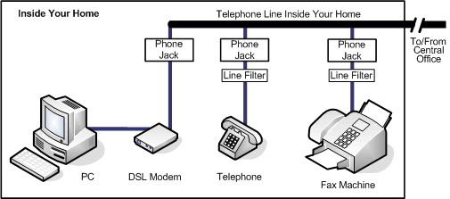
Internet delivered over telephone lines (DSL) or cable TV lines.
- Pros
- Widely available
- Affordable
- Faster than dial-up
- Easy installation
- Cons
- Speed drops with distance (DSL)
- Shared bandwidth (cable slows at peak hours)
- Slower than fiber
Best for: Homes, students, small offices
2. Fiber Optic Internet

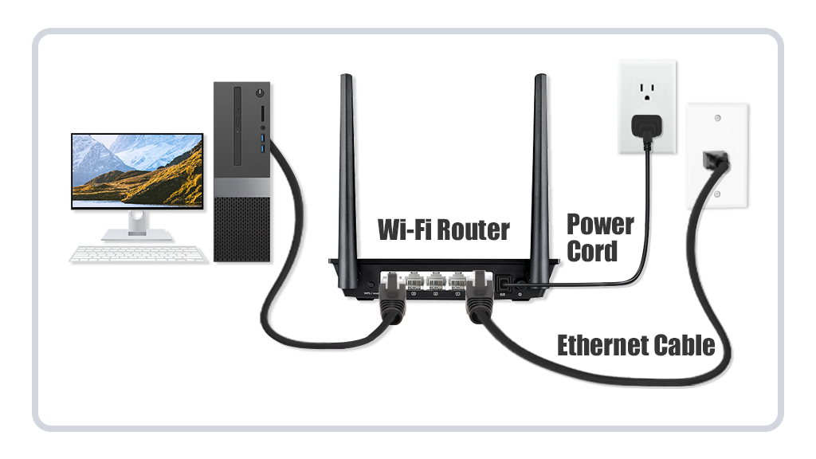
Uses fiber-optic cables that transmit data as light.
- Pros
- Extremely high speed (up to Gbps)
- Very low latency
- Reliable connection
- Same upload & download speed
- Cons
- Limited availability
- Expensive installation
- Not available in many rural areas
Best for: Streaming, gaming, cloud computing, businesses

3. Satellite Internet
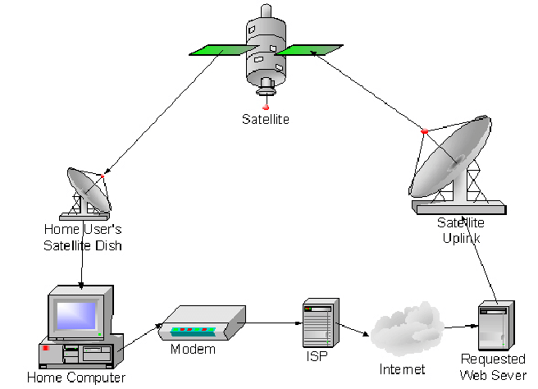
Internet provided via communication satellites.
- Pros
- Available in remote & rural areas
- No need for cables
- Wide coverage
- Cons
- High latency (slow response)
- Weather affects signal
- Expensive plans
- Lower speed than fiber/broadband
Best for: Remote villages, rural locations
4. Mobile Data (4G / 5G)

Internet via cellular networks using SIM cards.

Pros
- Portable
- Easy setup
- Fast (especially 5G)
- No wiring needed
- Cons
- Data limits
- Network congestion
- Speed depends on signal strength
- What are the differences between HTTP and HTTPS protocols?
Ans :-
Parameter | HTTP | HTTPS
URL | URLs in HTTP start with "http://" | URLs start with "https://"
Port | For communication, HTTP utilized port number 80. | HTTPS uses port 443.
Security | HTTP is thought to be unsecure. | HTTPS is regarded as a secure protocol.
OSI Layer | HTTP operates at the Application Layer. | HTTPS operates at the Transport Layer.
Encryption | There is no encryption in HTTP. | HTTPS encrypts the data.
SSL certificates | HTTP requires no certificates. | It requires SSL certificates.
LAB EXERCISE: Simulate HTTP and FTP requests using command line tools (e.g., curl).
Ans:- 1.Simulating HTTP Requests
HTTP (Hypertext Transfer Protocol) is the foundation of data exchange on the web. curl makes it easy to simulate different methods like GET and POST.

GET Request
A basic GET request retrieves data from a server.
- Command: curl https://jsonplaceholder.typicode.com/posts/1
- With Headers: To see the "conversation" between the client and server (the headers), add the -v (verbose) flag: curl -v https://www.google.com

POST Request
Used to send data to a server (like submitting a form).
- Command: ```bash curl -X POST https://www.google.com/search?q=https://jsonplaceholder.typicode.com/posts
-H "Content-Type: application/json"
-d '{"title": "Hello World", "body": "Testing curl", "userId": 1}'
2. Simulating FTP Requests
FTP (File Transfer Protocol) is designed specifically for moving files. While many modern servers use SFTP (Secure FTP), curl supports the classic syntax as well.

List Files on an FTP Server
To see what files are available in a directory:
- Command: curl ftp://ftp.example.com --user username:password

Download a File
To pull a file from the server to your local machine:
- Command: curl -u username:password -O ftp://ftp.example.com/file.zip (The -O flag saves the file with its original name.)

Upload a File
To push a local file to the server:
- Command: curl -u username:password -T localfile.txt ftp://ftp.example.com/remote/path/

- What is the role of encryption in securing application, Software Applications and Its Types
Ans :-
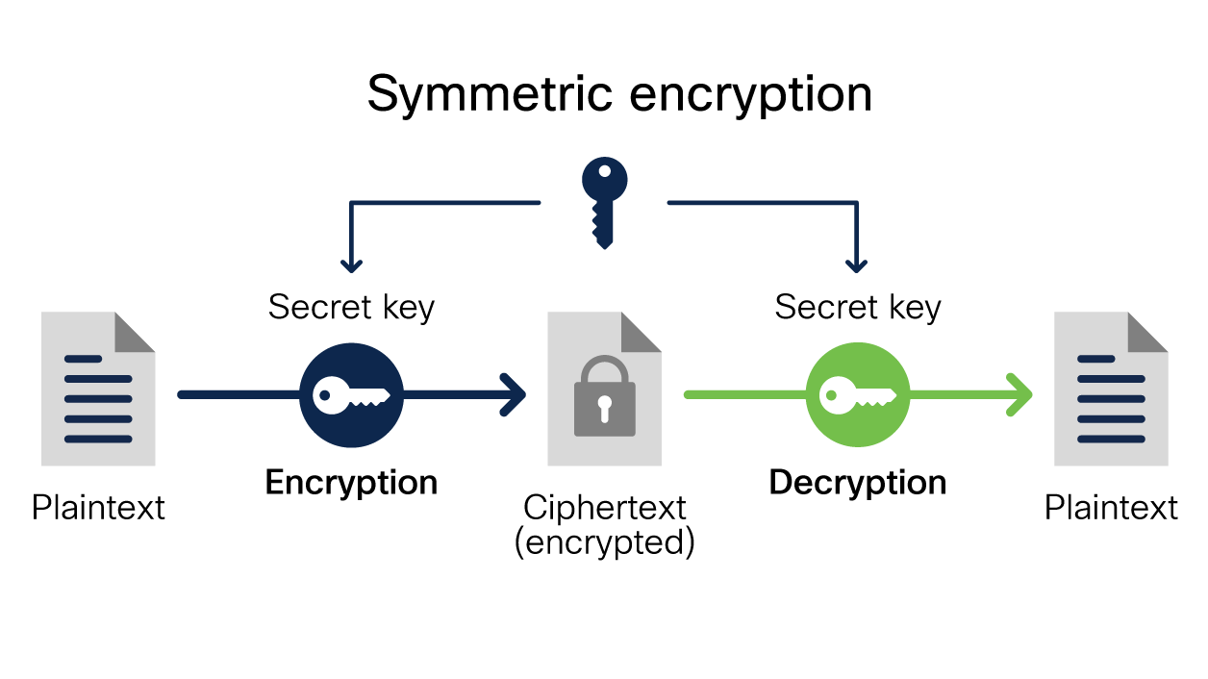
Encryption is a security technique used to protect data by converting it into an unreadable format so that only authorized users can access it. It plays a crucial role in securing applications and software systems from unauthorized access, data theft, and cyberattacks.
- Role of Encryption in Securing Applications
Encryption helps ensure confidentiality, integrity, and security of data in software applications.
Key roles include:
- Protecting sensitive user data (passwords, personal details, payment info)
- Securing data during transmission over networks
- Preventing unauthorized access and data leaks
- Ensuring secure login and authentication
- Building user trust in applications
Example:
When a user enters a password, encryption ensures it is stored or transmitted in a secure form rather than plain text.
- Role of Encryption in Software Applications
- Data at Rest: Protects stored data in databases and files
- Data in Transit: Secures data sent between client and server
- Authentication: Ensures safe identity verification
- Compliance: Helps meet security standards and regulations
- Types of Encryption

1. Symmetric Encryption
- Uses one secret key for both encryption and decryption
- Fast and efficient
- Key must be shared securely
Examples: AES, DES

2. Asymmetric Encryption
- Uses two keys: public key and private key
- More secure for key exchange
- Slower than symmetric encryption
Examples: RSA, ECC

3. Hashing (One-Way Encryption)
- Converts data into a fixed-length value
- Cannot be decrypted back
- Commonly used for password storage
Examples: SHA-256, MD5
LAB EXERCISE: Identify and explain three common application security vulnerabilities. Suggestpossible solutions.
Ans:- 1. Cross-Site Scripting (XSS)
This is the "Front-End Special." It’s our biggest headache. It happens when we take data from an API or a URL parameter and render it directly into the DOM without sanitizing it.
- The Front-End Risk: If I use innerHTML to display a user's bio, and that user set their bio to a <script> tag, I’ve just given them full control over every other user's session.
- The Solution:
  - Use Safe Methods: Always prefer .textContent or .innerText over .innerHTML. Modern frameworks like React help by escaping strings by default.
  - Sanitization Libraries: If you must render HTML (like from a CMS), use a library like DOMPurify to strip out dangerous tags.
2. Insecure Client-Side Logic (Broken Access Control)
Newer devs often make the mistake of hiding a "Delete" button via CSS (display: none) and thinking the feature is secure.
- The Front-End Risk: An attacker can just open the DevTools, find the button, remove the hidden class, and click it. If the backend doesn't re-verify that user's role, the action goes through.
- The Solution:
  - Never Trust the UI: Treat the UI as a "suggestion." Every sensitive action initiated in the front end must be validated by the API.
  - Route Guards: Use middleware in your SPA (Single Page App) to prevent users from navigating to /admin if their token doesn't have the right permissions.
3. Sensitive Data Exposure in Source Code
Since our code is shipped directly to the user's browser, anything we put in our JavaScript is public.
- The Front-End Risk: Hardcoding API keys, "secret" staging URLs, or internal comments in our codebases. Even if you minify your code, tools like "source maps" can reconstruct your original files for an attacker to read.
- The Solution:
  - Environment Variables: Use .env files and build tools (like Vite or Webpack) to inject keys at build time, and never commit secrets to GitHub.
  - Backend Proxies: For high-security API keys (like AWS secrets), don't call the service from the front end. Call your own backend, and let the backend handle the secret talk.

- What is the difference between system software and application software?
Ans :-
System Software | Application Software
System Software maintains the system resources and gives the path for application software to run. | Application software is built for specific tasks.
Low-level languages are used to write the system software. | While high-level languages are used to write the application software.
It is general-purpose software. | While it's a specific purpose software.
Without system software, the system stops and can't run. | While Without application software system always runs.
System software runs when the system is turned on and stops when the system is turned off. | While application software runs as per the user's request.
Example: System software is an operating system, etc. | Example: Application software is Photoshop, VLC player, etc.
System Software programming is more complex than application software. | Application software programming is simpler in comparison to system software.
The Software that is designed to control, integrate and manage the individual hardware components and application software is known as system software. | A set of computer programs installed in the user's system and designed to perform a specific task is known as application software.
A system software operates the system in the background until the shutdown of the computer. | Application software runs in the front end according to the user's request.
The system software has no interaction with users. It serves as an interface between hardware and the end user. | Application software connects an intermediary between the user and the computer.
LAB EXERCISE: Identify and classify 5 applications you use daily as either system software orapplication software.
Ans:- 1. macOS / Windows / Linux
Classification: System Software (Operating System) This is the foundational layer. As a dev, this manages your file system, memory, and hardware resources. Without it, your laptop is just a very expensive brick of aluminum and glass.
2. Visual Studio Code
Classification: Application Software Even though it feels like our entire world, VS Code is a specialized application designed for a specific task (coding). Under the hood, it’s actually an Electron app—essentially a high-performance web browser optimized for text editing.
3. Google Chrome (or any Browser)
Classification: Application Software Browsers are interesting. While they act as an "operating system" for our web apps, they are technically application software. They use a rendering engine (like Blink or WebKit) to turn your HTML, CSS, and JS into a visual interface.
4. Node.js
Classification: System Software (Middleware/Runtime) While some argue this, in a front-end workflow, Node.js acts as system-level software. It provides the runtime environment that allows your build tools (like Vite or Webpack) to interact with your computer's file system to bundle your code.
5. Slack / Discord
Classification: Application Software These are "End-user" applications. They sit at the top of the stack and use the network capabilities provided by the System Software to let you send messages and memes to your team.
- What is the significance of modularity in software architecture?
Ans :- Modularity in software architecture refers to designing a system by dividing it into smaller, independent, and manageable units called modules. Each module performs a specific function and interacts with other modules through well-defined interfaces.
- Significance of Modularity
- Improved Maintainability
Changes can be made to one module without affecting the entire system.
- Reusability
Modules can be reused in different projects, saving time and effort.
- Better Readability & Organization
Code becomes easier to understand and manage.
- Parallel Development
Multiple developers or teams can work on different modules at the same time.
- Scalability
New features can be added by extending or replacing modules.
- Easier Testing & Debugging
Individual modules can be tested independently, making bugs easier to find.
- Fault Isolation
Errors in one module do not easily spread to other parts of the system.
LAB EXERCISE: Design a basic three-tier software architecture diagram for a web application.
Ans:-
1. Presentation Tier (The Browser/Client)
- Your Code: React components, CSS modules, Vite/Webpack configs.
- Action: You make a request: fetch('/api/users').
2. Logic Tier (The API/Server)
- The Bridge: This is the middleware. It receives your fetch, checks if the user is logged in, and decides what to do next.
- Action: It writes a query: SELECT * FROM users.
3. Data Tier (The Database)
- The Source: This is the "Source of Truth." It holds the tables and records.
- Action: It returns the raw data to the Logic Tier, which then sends it back to you as JSON.
- Why are layers important in software architecture?
Ans :-
- Importance of Layers
- Separation of Responsibilities
Each layer focuses on a single task, such as user interface, business logic, or data management.
- Easy Maintenance
Changes in one layer can be made without affecting other layers.
- Better Code Organization
Code becomes cleaner, structured, and easier to understand.
- Scalability
Individual layers can be upgraded or expanded independently.
- Reusability
Logic and data layers can be reused across different applications.
- Simpler Testing and Debugging
Each layer can be tested separately, reducing errors.
- Improved Security
Sensitive data and operations are isolated in secure layers.
LAB EXERCISE: Create a case study on the functionality of the presentation, business logic, and data access layers of a given software system.
Ans:- Case Study: "SwiftShop" E-Commerce System
1. Presentation Layer (The "User's World")
This is the Client-Side application. In our case study, it’s a Single Page Application (SPA) built with Next.js.
- Functionality: * Renders the product catalog using interactive components.
  - Manages the "Shopping Cart" state locally (so the UI feels instant).
  - Captures user events (clicks, form inputs, searches).
- The Front-End Responsibility: We ensure that when a user clicks "Add to Cart," the UI updates immediately (optimistic UI), even before the server confirms it.
- Communication: It uses JSON over HTTPS to talk to the layers below.
2. Business Logic Layer (The "Rules of the Game")
This is the Server-Side application, often running on Node.js/Express. This layer doesn't care about CSS or button colors; it only cares about data integrity and rules.
- Functionality:
  - Validation: When the Presentation Layer says "User wants to buy 500 laptops," this layer checks if that's actually allowed or physically possible.
  - Calculations: It calculates the total price, applies discount codes, and adds sales tax based on the user's location.
  - Integration: It talks to 3rd-party services (like Stripe for payments or FedEx for shipping).
- The Front-End Connection: This is where our API endpoints live (e.g., POST /api/v1/orders).
3. Data Access Layer (The "Memory Bank")
This layer consists of the Database (PostgreSQL) and the code used to talk to it (like an ORM like Prisma or Sequelize).
- Functionality:
  - Persistence: It ensures that if the server crashes, the user's order isn't lost.
  - Querying: It finds the specific product details from millions of rows in a split second.
  - Security: It restricts access so the Presentation Layer can't accidentally "see" other users' credit card info.
- The Data Flow: It receives a command from the Logic Layer (e.g., UPDATE inventory SET stock = stock - 1 WHERE id = 'laptop-123').

- Explain the importance of a development environment in software production.
Ans :-
- Why a Development Environment Is Important
- Efficient Software Development
Tools like code editors, compilers, and debuggers help developers write and manage code faster.
- Error Detection and Debugging
Built-in debugging and error-checking tools help identify and fix issues early.
- Consistent Development Process
Ensures uniform tools, configurations, and standards across the team.
- Testing Before Release
Allows software to be tested safely before deployment to production.
- Improved Code Quality
Supports best practices through linting, formatting, and testing tools.
- Collaboration Support
Integrates with version control systems for team-based development.
- Faster Maintenance and Updates
Makes it easier to update and improve software after release.
- Components of a Development Environment
- Code editor or IDE
- Compiler or interpreter
- Debugging tools
- Version control system
- Testing and build tools
LAB EXERCISE: Explore different types of software environments (development, testing, production).Set up a basic environment in a virtual machine.
Ans:- Types of Software Environments
1. Development Environment
Purpose:
Used by developers to write, modify, and debug code.
Key Features:
- Source code editors (VS Code, IDEs)
- Debugging tools
- Local databases / mock APIs
- Frequent changes allowed
Pros:
- Fast experimentation
- Easy debugging
- Flexible configuration
Cons:
- Not stable
- Not suitable for end users
2. Testing Environment
Purpose:
Used to test software functionality, performance, and security before release.
Key Features:
- Same configuration as production
- Test databases
- Automated/manual testing tools
Pros:
- Detects bugs early
- Improves software quality
Cons:
- Extra cost and setup
- Slower than development

3. Production Environment
Purpose:
Where the final application runs for real users.
Key Features:
- High security
- Optimized performance
- Real user data
- Monitoring & logging
Pros:
- Stable and reliable
- Real-world usage
Cons:
- Changes are risky
- Bugs directly affect users

- What is the difference between source code and machine code?
Ans :-
Feature | Source Code | Machine Code
Readability | Human-readable | Not readable
Language | High / Low-level | Binary
Execution | Needs compiler/interpreter | Runs directly on CPU
Modification | Easy | Very difficult
Portability | Platform independent | Hardware dependent
LAB EXERCISE: Write and upload your first source code file to Github.
Ans:- 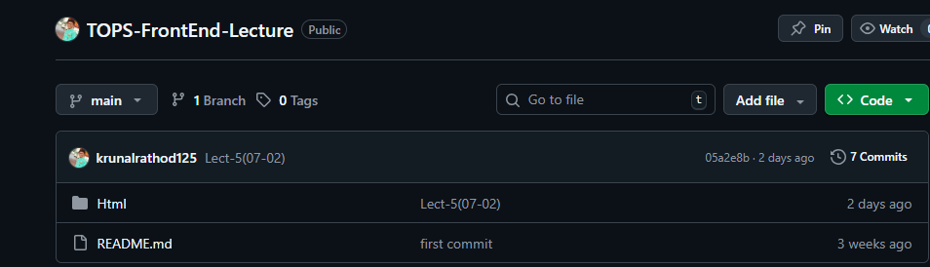
- Why is version control important in software development?
Ans :-
- Importance of Version Control
- Tracks Code Changes
Keeps a complete history of who changed what and when.
- Enables Team Collaboration
Multiple developers can work on the same project without overwriting each other’s work.
- Easy Rollback
If a bug or mistake occurs, the project can be reverted to a previous stable version.
- Improves Code Safety
Prevents loss of code due to accidental deletion or errors.
- Supports Experimentation
Developers can create branches to try new features without affecting the main codebase.
- Better Project Management
Helps manage releases, updates, and bug fixes systematically.
- Ensures Code Consistency
Maintains a single source of truth for the project.
LAB EXERCISE: Create a Github repository and document how to commit and push code changes.
Ans:- 
- Commands For Commit and Push code changes
      - cd ..
      - git status
      - git add .
      - git commit -m “message”
      - git push -u origin main
- What are the benefits of using Github for students?
Ans :-
- Key Benefits of GitHub for Students
- Version Control Practice
Helps students track changes in code and understand how version control works in real projects.
- Improves Collaboration Skills
Enables teamwork through features like repositories, branches, pull requests, and issues.
- Builds a Strong Portfolio
Students can showcase their projects publicly, which is useful for internships and job interviews.
- Real-World Development Experience
Provides hands-on experience with industry-standard tools used by professionals.
- Easy Project Management
Helps organize code, track bugs, and manage tasks efficiently.
- Access to Open-Source Projects
Students can learn by exploring and contributing to real-world open-source projects.
- Free Learning Resources
Offers access to tutorials, documentation, and community support.
- GitHub Student Developer Pack
Provides free access to premium tools, software, and cloud services for learning.
LAB EXERCISE: Create a student account on Github and collaborate on a small project with a classmate.
- What are the differences between open-source and proprietary software?
Ans :
- Open-Source Software
Open-source software allows users to view, modify, and distribute the source code freely.
Characteristics:
- Source code is publicly available
- Free to use and modify
- Community-driven development
- Highly customizable
- Transparent and secure through community review
Examples:
- Linux
- Mozilla Firefox
- LibreOffice
- Proprietary Software
Proprietary software is owned by a company or individual, and its source code is not accessible to users.
Characteristics:
- Source code is closed
- Requires a paid license (usually)
- Limited customization
- Controlled and maintained by the owner
- Official customer support available
Examples:
- Microsoft Windows
- Microsoft Office
- Adobe Photoshop
LAB EXERCISE: Create a list of software you use regularly and classify them into the following categories: system, application, and utility software.
Ans:- System Software
Definition:
System software controls hardware and provides a platform for running applications.
Examples I use regularly:
- Windows 10 / Windows 11 – Operating system
- Linux (Ubuntu) – Operating system
- Android – Mobile operating system
- Device Drivers (printer, graphics driver)
Purpose:
- Manages hardware
- Runs application software
- Controls system resources
2️. Application Software
Definition:
Application software is designed to perform specific user tasks.
Examples I use regularly:
- Google Chrome – Web browsing
- Microsoft Word – Document creation
- Microsoft Excel – Spreadsheets
- Visual Studio Code – Code editing
- Zoom / Google Meet – Online meetings
- WhatsApp – Communication
- YouTube – Media streaming
Purpose:
- Helps users perform daily tasks
- Directly interacts with users

  - Utility Software
Definition:
Utility software is used for system maintenance, optimization, and security.
Examples I use regularly:
- Antivirus (Windows Defender)
- Disk Cleanup
- File Compression tools (WinRAR / 7-Zip)
- Backup tools
- Task Manager
Purpose:
- Improves system performance
- Protects data
- Maintains system health
- How does GIT improve collaboration in a software development team?
Ans :- Git is a distributed version control system that helps multiple people work on the same project at the same time without conflicts. It makes team collaboration organized, safe, and efficient.
- Git Improves Team Collaboration
- Parallel Development
Team members can work on different features or files simultaneously using branches.
- Branching and Merging
Each developer works on their own branch and later merges changes into the main branch safely.
- Change Tracking
Git keeps a complete history of changes, showing who made what changes and when.
- Conflict Management
Git detects conflicts when changes overlap and helps resolve them systematically.
- Code Review Support
Git platforms allow team members to review code before merging, improving code quality.
- Easy Rollback
If something breaks, Git allows reverting to a previous stable version.
- Distributed System
Every developer has a full copy of the repository, reducing dependency on a single server.
LAB EXERCISE: Follow a GIT tutorial to practice cloning, branching, and merging repositories.
- What is the role of application software in businesses?
Ans :- Application software plays a vital role in businesses by helping organizations perform specific tasks efficiently, improve productivity, and manage operations effectively. These software programs are designed to meet business needs such as communication, data management, accounting, and customer service.
- Key Roles of Application Software in Businesses
- Improves Productivity
Automates routine tasks like data entry, reporting, and documentation, saving time and effort.
- Supports Business Operations
Helps manage daily activities such as sales, inventory, payroll, and customer records.
- Enhances Communication
Enables email, video conferencing, and team collaboration for smooth internal and external communication.
- Data Management and Analysis
Stores, processes, and analyzes large volumes of business data to support decision-making.
- Customer Relationship Management
Helps businesses manage customer interactions, feedback, and services efficiently.
- Financial Management
Assists in accounting, billing, budgeting, and financial reporting.
- Improves Accuracy and Efficiency
Reduces human errors and ensures consistent business processes.
- Supports Growth and Scalability
Software systems can be upgraded as the business expands.
LAB EXERCISE: Write a report on the various types of application software and how they improveproductivity.
- What are the main stages of the software development process?
Ans :- The software development process, often called the Software Development Life Cycle (SDLC), is a structured approach used to build high-quality software in an organized and efficient way.

- Main Stages of the Software Development Process
- Requirement Analysis
Understand what the users need and define the goals, features, and constraints of the software.
- Planning
Decide timelines, resources, technologies, and development strategies.
- System Design
Create the software architecture, data models, and overall system structure.
- Development (Coding)
Write the actual program code based on the design specifications.
- Testing
Check the software for errors, bugs, and performance issues to ensure it works correctly.
- Deployment
Release the software to users or make it live in the production environment.
- Maintenance
Fix bugs, update features, and improve performance after deployment.
LAB EXERCISE: Create a flowchart representing the Software Development Life Cycle (SDLC).
Ans:-
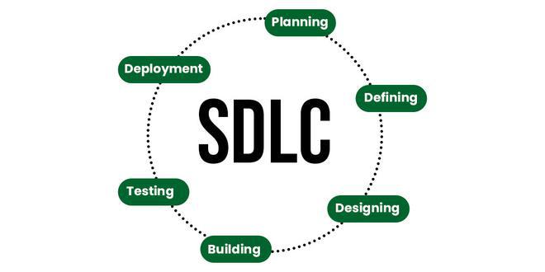

- Why is the requirement analysis phase critical in software development?
Ans :-
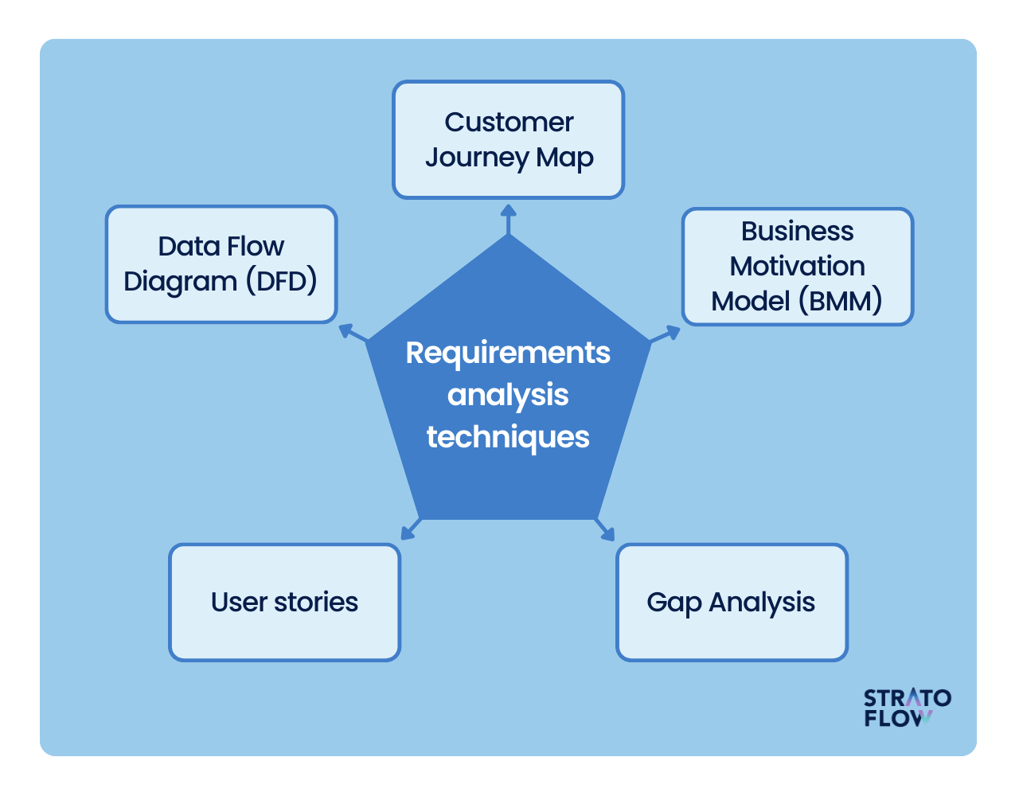
The requirement analysis phase is one of the most important stages of the software development process. It focuses on understanding what the user needs before any design or coding begins.
- Importance of Requirement Analysis
- Clear Understanding of User Needs
Ensures the software solves the right problem and meets user expectations.
- Reduces Development Errors
Identifying requirements early prevents costly changes later.
- Defines Project Scope
Clearly outlines what features are included and excluded, avoiding scope creep.
- Improves Planning and Estimation
Helps estimate time, cost, and resources accurately.
- Provides a Strong Foundation
Serves as a blueprint for design, development, and testing phases.
- Enhances Communication
Acts as a common reference between stakeholders, developers, and testers.
- Ensures Quality Software
Well-defined requirements lead to better design and fewer defects.

LAB EXERCISE: Write a requirement specification for a simple library management system.
Ans:- Library Management System
1. Introduction
1.1 Purpose
The purpose of this document is to describe the functional and non-functional requirements of a Library Management System (LMS). The system is designed to automate library operations such as book management, member management, and book issuing/returning.
1.2 Scope
The Library Management System will help librarians manage books and users efficiently. It reduces manual work, improves accuracy, and provides quick access to library information.

1.3 Intended Users
- Librarian / Administrator
- Library Members (Students/Staff)
2. Overall Description

2.1 System Overview
The system is a software application that maintains records of books, members, and transactions. It allows issuing and returning of books and keeps track of availability.

2.2 Operating Environment
- Platform: Desktop or Web-based application
- Operating System: Windows / Linux
- Database: MySQL or similar
- Programming Language: Java / Python / PHP (any suitable language)

2.3 Assumptions
- Only authorized users can access the system
- Librarian has full control over the system
- Users have basic computer knowledge
3. Functional Requirements

3.1 User Authentication
- The system shall allow users to log in using username and password
- The system shall restrict access based on user roles

3.2 Book Management
- The system shall allow the librarian to add new books
- The system shall allow updating book details
- The system shall allow deleting book records
- The system shall display available and issued books

3.3 Member Management
- The system shall allow adding new members
- The system shall allow updating member details
- The system shall allow deleting member records

3.4 Book Issue
- The system shall allow issuing books to members
- The system shall record issue date and due date
- The system shall prevent issuing unavailable books

3.5 Book Return
- The system shall allow returning issued books
- The system shall update book availability
- The system shall calculate late fines if applicable

3.6 Search Functionality
- The system shall allow searching books by title, author, or category
- The system shall display search results quickly
4. Non-Functional Requirements

4.1 Performance
- The system shall respond within 2 seconds
- The system shall handle multiple users simultaneously

4.2 Security
- The system shall protect user credentials
- The system shall restrict unauthorized access

4.3 Usability
- The system shall have a user-friendly interface
- The system shall be easy to learn and use

4.4 Reliability
- The system shall ensure data consistency
- The system shall recover data in case of failure
5. System Constraints
- Internet connection required for web-based system
- Limited to basic library operations
- Depends on database availability
6. Future Enhancements
- Online book reservation
- Email notifications for due dates
- Barcode/RFID support
- Report generation
- What is the role of software analysis in the development process?
Ans :- Software analysis is the foundation of successful software development. It focuses on understanding what needs to be built before deciding how to build it.
- Main Roles of Software Analysis
- Understanding User Requirements
It gathers and clearly defines user needs, expectations, and business goals so the final software solves the right problem.
- Reducing Errors & Rework
By identifying gaps, conflicts, or missing requirements early, software analysis prevents costly fixes later in development.
- Defining System Scope
It sets clear boundaries for what the software will and will not do, helping avoid scope creep.
- Improving Design Quality
Well-analyzed requirements lead to better system architecture, database design, and technology choices.
- Facilitating Communication
Acts as a bridge between stakeholders, developers, and testers by translating business needs into technical requirements.
- Supporting Planning & Estimation
Helps in estimating time, cost, resources, and risks more accurately.
- Ensuring Quality & Compliance
Confirms that functional and non-functional requirements (performance, security, usability) are met.
LAB EXERCISE: Perform a functional analysis for an online shopping system.
Ans:- Functional Requirements Table
Module | Main Functions
User Management | Register, login, profile
Product Management | Add, update, view products
Search & Browse | Search, filter, sort
Cart | Add, update, remove items
Orders | Place, view, cancel
Payment | Secure transaction
Inventory | Stock management
Delivery | Shipping & tracking
Admin | Control & reporting

- What are the key elements of system design?
Ans :- System design defines how the system will be built to meet the requirements identified during analysis. It acts as a blueprint for developers.

Elements of System Design
- Architecture Design
Defines the overall structure of the system (client–server, layered, MVC, microservices, etc.).
- Data Design
Specifies how data is stored, accessed, and managed (databases, tables, relationships, data flow).
- Component / Module Design
Breaks the system into smaller modules or components and defines their responsibilities.
- Interface Design
Covers user interfaces (UI) and system interfaces (APIs) for interaction between users and other systems.
- Process Design
Describes the logic, workflows, and interactions between components during system operation.
- Security Design
Defines authentication, authorization, data encryption, and protection against threats.
- Performance & Scalability Design
Ensures the system can handle expected load, speed, and future growth.
- Hardware & Software Specification
Identifies required hardware, operating systems, programming languages, frameworks, and tools.
- Why is software testing important?
Ans :- Software testing is essential to ensure that a software application works correctly, safely, and efficiently before it is released to users.
- Finds Bugs and Errors
Testing detects defects early, reducing the cost and effort of fixing them later.
- Ensures Quality and Reliability
Confirms that the software performs as expected under different conditions.
- Improves User Experience
Identifies usability issues so the software is easy and smooth to use.
- Enhances Security
Testing helps detect vulnerabilities that could lead to data breaches or system failures.
- Validates Requirements
Ensures the software meets user and business requirements accurately.
- Reduces Failure Risk
Prevents system crashes, data loss, and performance issues after deployment.
- Builds Customer Confidence
Reliable and well-tested software increases user trust and satisfaction.

LAB EXERCISE: Design a basic system architecture for a food delivery app.
Ans:-
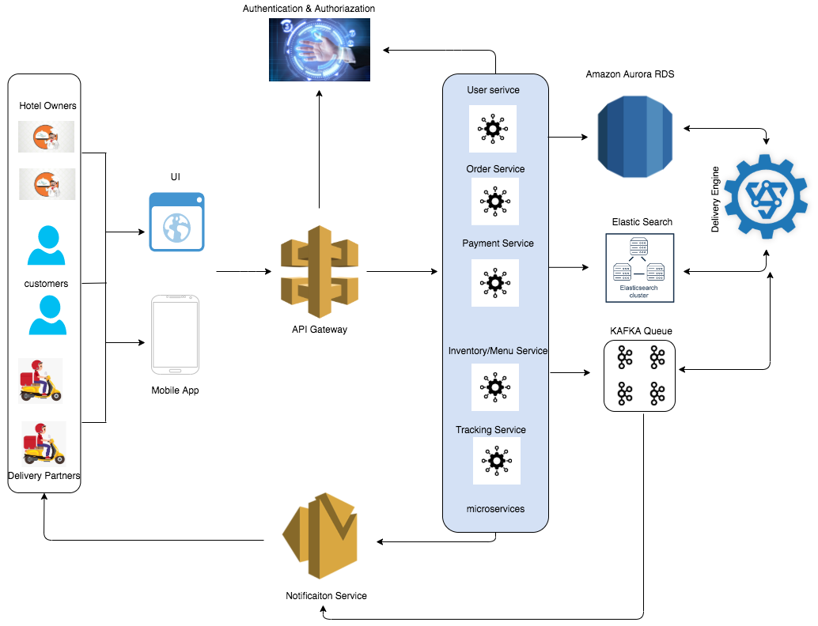
- Why is software testing important?
Ans:-
LAB EXERCISE: Develop test cases for a simple calculator program.
Ans:-
- What types of software maintenance are there?
Ans :- Software maintenance refers to the activities performed after software deployment to keep it running smoothly, efficiently, and up to date.

Main Types of Software Maintenance
- Corrective Maintenance
  - Fixes bugs, errors, and defects found after release.
  - Example: Fixing a login error in a live application.
- Adaptive Maintenance
  - Modifies software to work in a new environment.
  - Example: Updating software to run on a new operating system or browser.
- Perfective Maintenance
  - Improves performance, usability, or adds new features based on user feedback.
  - Example: Adding a dark mode or improving page load speed.
- Preventive Maintenance
  - Improves code structure to prevent future problems.
  - Example: Refactoring code to reduce complexity.
LAB EXERCISE: Document a real-world case where a software application required criticalmaintenance.
Ans:- 1. Introduction
In May 2017, a global cyberattack known as WannaCry affected hundreds of thousands of computers worldwide. The attack targeted systems running Microsoft Windows by exploiting a vulnerability in the Windows operating system. This incident is a well-known example of why critical software maintenance is essential.
2. Background of the Problem
WannaCry was a ransomware attack that encrypted user data and demanded payment in Bitcoin to restore access.
The malware exploited a security vulnerability in Windows’ file-sharing protocol (SMB).
Although Microsoft had already released a security patch for this vulnerability, many systems had not installed the update, making them vulnerable.
3. Impact of the Failure
The attack caused major disruptions across the world:
- Hospitals were unable to access patient records
- Businesses lost access to critical data
- Public services and transportation systems were affected
- Over 200,000 computers in 150+ countries were infected
This showed that unmaintained software can lead to large-scale failures.
4. Critical Maintenance Actions Taken

4.1 Emergency Security Patches
Microsoft released emergency patches, even for older Windows versions that were no longer officially supported.

4.2 System Updates
Organizations were instructed to:
- Immediately install security updates
- Enable automatic updates
- Remove outdated software

4.3 Network and System Hardening
- SMB protocol was disabled where not required
- Firewalls and antivirus systems were updated
- Regular system scans were enforced
5. Type of Maintenance Involved
This incident required Corrective and Preventive Maintenance:
- Corrective Maintenance: Fixing the exploited vulnerability
- Preventive Maintenance: Applying patches to prevent future attacks
6. Lessons Learned
- Ignoring software updates can lead to severe consequences
- Regular maintenance is critical for system security
- Organizations must apply patches promptly
- Legacy systems pose high security risks
- What are the key differences between web and desktop applications?
Ans :-
Aspect | Web Application | Desktop Application
Platform | Runs in a web browser | Runs on a specific operating system
Installation | No installation required | Must be installed on the computer
Internet Requirement | Usually requires internet | Can work offline
Accessibility | Accessible from any device with a browser | Limited to the device where installed
Updates | Automatic (server-side updates) | Manual updates required
Performance | Depends on browser and internet speed | Generally faster and more powerful
Storage | Data stored on servers/cloud | Data stored locally on the system
Security | Depends on server & browser security | Depends on local system security

- What role does UI/UX design play in application development?
Ans :- UI/UX design plays a crucial role in how users interact with an application. It focuses on making the app easy to use, visually appealing, and efficient.

Roles of UI/UX Design
- Enhances User Satisfaction
A clean and intuitive design makes users feel comfortable and confident while using the application.
- Improves Usability
UX design ensures smooth navigation, logical workflows, and minimal effort to complete tasks.
- Increases User Engagement
Attractive UI elements and smooth interactions keep users engaged and encourage repeated use.
- Reduces User Errors
Clear layouts, proper feedback, and simple forms help users avoid mistakes.
- Saves Development Cost
Identifying usability issues early reduces rework and costly changes later.
- Strengthens Brand Identity
Consistent colors, fonts, and layouts create a strong and professional brand image.
- What are the differences between native and hybrid mobile apps?
Ans :-
Aspect | Native Mobile Apps | Hybrid Mobile Apps
Technology Used | Platform-specific languages (Java/Kotlin for Android, Swift for iOS) | Web technologies (HTML, CSS, JavaScript)
Platform Support | Separate app for each platform | Single app works on multiple platforms
Performance | High performance and fast | Slightly slower than native
User Experience | Best UI/UX, matches platform standards | UI/UX may feel less native
Access to Device Features | Full access (camera, GPS, sensors) | Limited access via plugins
Development Cost | Higher (multiple codebases) | Lower (single codebase)
Maintenance | More effort required | Easier to maintain

- What is the significance of DFDs in system analysis?
Ans :- DFDs are a powerful tool used in system analysis to visually represent how data flows through a system. They focus on what data is processed rather than how the system is implemented.

Why DFDs Are Important
- Clear Understanding of the System
DFDs show how data moves between users, processes, and databases in a simple, visual way.
- Improves Communication
Easy for both technical and non-technical stakeholders to understand, reducing misunderstandings.
- Identifies System Boundaries
Clearly defines what is inside the system and what lies outside (external entities).
- Helps Detect Errors Early
Missing data flows, redundant processes, or incorrect logic can be spotted early.
- Supports Better System Design
Acts as a foundation for designing databases, processes, and program modules.
- Encourages Structured Analysis
Helps break a complex system into smaller, manageable processes (Level 0, Level 1, etc.).
LAB EXERCISE: Create a DFD for a hospital management system.
Ans:-
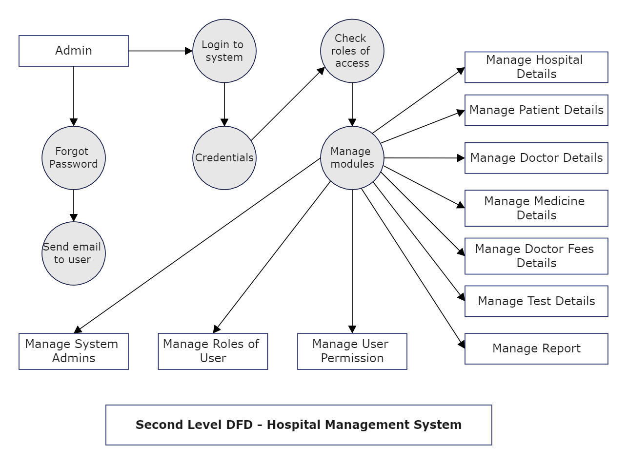
- What are the pros and cons of desktop applications compared to web applications?
Ans :- Desktop applications and web applications each have their own strengths and limitations.

Pros of Desktop Applications (over Web Apps)
- Better Performance
Desktop apps run directly on the system hardware, so they are usually faster and smoother.
- Offline Access
They can work without an internet connection.
- Full System Access
Easy access to local files, hardware devices, printers, and system resources.
- Higher Security for Local Data
Sensitive data can be stored locally without relying on the internet.
- Rich User Interface
Supports complex UI features and heavy graphics more easily.

Cons of Desktop Applications (compared to Web Apps)
- Installation Required
Users must download and install the software on each device.
- Platform Dependency
Separate versions are needed for Windows, macOS, and Linux.
- Manual Updates
Users often need to update the application themselves.
- Limited Accessibility
Can only be used on the device where it is installed.
- Higher Maintenance Cost
Supporting multiple platforms increases development and maintenance effort.
LAB EXERCISE: Build a simple desktop calculator application using a GUI library.
Ans:-
- How do flowcharts help in programming and system design?
Ans :- Flowcharts are visual diagrams that represent the step-by-step flow of logic or processes in a system or program. They make complex logic easy to understand and plan.

Importance of Flowcharts
- Simplifies Complex Logic
Flowcharts break down complicated processes into clear, logical steps.
- Improves Problem Understanding
Helps programmers and designers understand the problem before writing code.
- Better Planning of Programs
Acts as a blueprint that guides coding and system implementation.
- Enhances Communication
Easy to explain system logic to team members and non-technical stakeholders.
- Error Detection
Logical mistakes and missing steps can be identified early.
- Supports Debugging & Maintenance
Makes debugging and future modifications easier.
- Provides Proper Documentation
Serves as visual documentation for systems and programs.
LAB EXERCISE: Draw a flowchart representing the logic of a basic online registration system.
Ans:-

